LAB # 06
OBJECTIVE
Implementing Inheritance in C#
Inheritance
Inheritance is a mechanism of extending existing classes without modifying them, thus you can create a general class that defines traits common to a set of related items. This class can then be inherited by other, more specific classes, each adding those things that are unique to it.
Inheritance is one of the three foundational principles of object-oriented programming because it allows the creation of hierarchical classifications
In the language of C#, a class that is inherited is called a base class. The class that does the inheriting is called a derived class. Therefore, a derived class is a specialized version of a base class. It inherits all of the variables, methods properties defined by the base class and add its own unique elements.
The idea of inheritance implements the is-a relationship. For example,

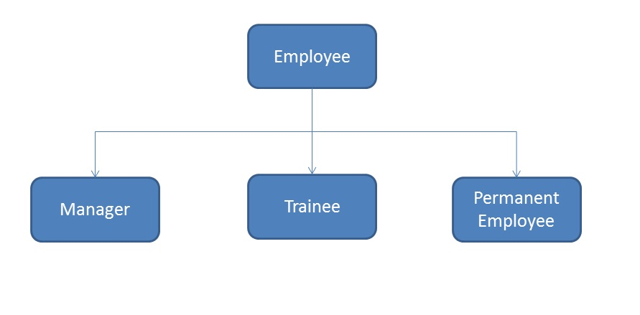

General Syntax
SomeClass //Base Class
{
…
} Class-base specification
↓
class OtherClass : SomeClass //Derived Class
{ ↑ ↑
... Colon Base class
}

Access Control and Inheritance
A derived class can access all the non-private members of its base class. Thus base-class members that should not be accessible to the member functions of derived classes should be declared private in the base class

We can summarize the different access types according to who can access them in the following way:

Access public protected private
Same class yes yes yes
Derived classes yes yes no
Outside classes yes no no
Example-1
using System;
class Citizen
{
string idNumber = "111-2345-H";
string name = "ABC";

public void GetPersonalInfo()
{
Console.WriteLine("Name: {0}", name);
Console.WriteLine("ID Card Number: {0}", idNumber);
}
}
class Employee: Citizen
{
string companyName = "Technology Group Inc.";
string companyID = "ENG-RES-101-C";

public void GetInfo()
{
Console.WriteLine("Citizen's Information:");
GetPersonalInfo();
Console.WriteLine("\nJob Information:");
Console.WriteLine("Company Name: {0}", companyName);
Console.WriteLine("Company ID: {0}", companyID);
}
}
class MainClass
{
public static void Main()
{
Employee E = new Employee();
E.GetInfo();
}
}

Output
Citizen's Information:
Name: ABC
ID card Number: 111-2345-H
Job Information:
Company Name: Technology Group Inc.
Company ID: ENG-RES-101-C

Multilevel Inheritance
In C# programming, a class be can derived from a derived class which is known as multilevel inheritance

General Syntax:
class A
{ }
class B : A
{ }
class C : B
{ }
class D : C
{ }
example :
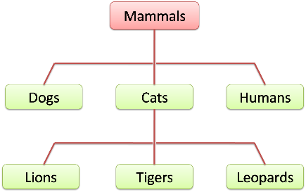

using System;
namespace Multilevel_inheritance
{
class TwoDShape
{
public double width;
public double height;

public void showDim()
{
Console.WriteLine("Width is :" + width);

Console.WriteLine("Height is :" + height);
}

}
class Triangle : TwoDShape
{
public string style;
public double Area()
{
return width * height / 2;
}
public void ShowStyle()
{
Console.WriteLine("Style of Triangle is: " + style);
}
}
class ColorTriangle : Triangle
{
public string color;
public void ShowColor()
{
Console.WriteLine("Color Of Triangle is:"+ color);
}
}

class Shapes
{
static void Main(string[] args)
{
ColorTriangle c = new ColorTriangle();
Console.WriteLine("Enter Width Of Triangle:");
c.width = Convert.ToDouble(Console.ReadLine());
Console.WriteLine("Enter Height Of Triangle:");
c.height= Convert.ToDouble(Console.ReadLine());
Console.WriteLine("Enter Style Of Triangle:");
c.style =Console.ReadLine();
Console.WriteLine("Enter Color Of Triangle:");
c.color = Console.ReadLine();
Console.WriteLine("-----------Triangle---------------");
c.showDim();
c.ShowStyle();
c.ShowColor();
Console.WriteLine("Area Of Triangle is: "+ c.Area());
Console.ReadKey();

}
}
}

TASK

Q1. Create an inheritance hierarchy that a bank might use to represent customers’ bank accounts.
All customers at this bank can deposit (i.e., credit) money into their accounts and withdraw (i.e., debit) money from their accounts. More specific types of accounts also exist. Savings accounts, for instance, earn interest on the money they hold. Checking accounts, on the other hand, charge a fee per transaction (i.e., credit or debit).

Create base class Account and derived classes Savings-Account and Checking Account that inherit from class Account. Base class Account should include
- Data member account balance (double)
- Member function credit should add an amount to the current balance.
- Member function debit should withdraw money from the Account and ensure that the debit amount does not exceed the Account’s balance. If it does, the balance should be left unchanged and the function should print the message "Debit amount exceeded account balance."
- Member function getBalance should return the current balance.

Derived class SavingsAccount should inherit Account, include
- A data member interest rate (percentage) assigned to the Account.
- Member function calculateInterest that returns a double indicating the amount of interest earned by an account.
(Member function calculateInterest should determine this amount by multiplying the interest rate by the account balance)
Derived class CheckingAccount should inherit Account and include

- An additional data member of type double that represents the fee charged per transaction.
- Member functions credit and debit so that they subtract the fee from the account balance whenever either transaction is performed successfully.
- CheckingAccount’s versions of these functions should invoke the base-class Account version to perform the updates to an account balance.
- CheckingAccount’s debit function should charge a fee only if money is actually withdrawn
(i.e., the debit amount does not exceed the account balance).

Q2. Generate a marksheet of different departments with proper record and calculate percentage with average of different subjects using Multilevel inheritance.

